Constraint Graph:
The constraint graph consists of four nodes representing X₁ ,X₂, X₃ and X₄​. The directed edges represent constraints:
- X₁ ≥ X₂​ (directed from X₂​ to X₁​)
- X₂ > X₃ (directed from X₃​ to X₂​)
- X₃ ≠ X₄​ (undirected between X₃​ and X₄)
The graph would look like this:

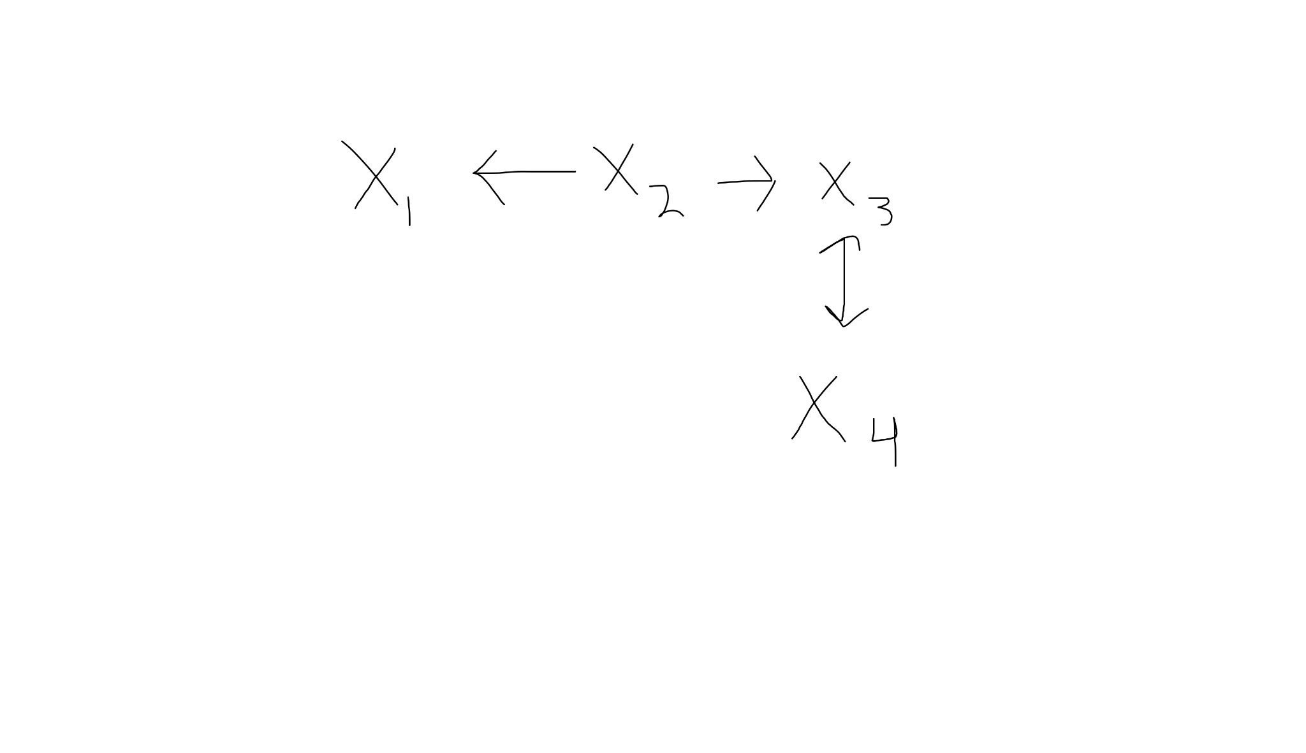

Applying AC-3 Algorithm:
The initial queue contains arcs:
{(X₂, X₁),(X₃, X₂),(X₃, X₄),(X₄, X₃)}
Processing each arc:
(X₂, X₁):
- X₁ ≥ X₂​ means X₁​ must be at least as large as X₂​.
- Check domain pairs:
  - If X₂ = 3, valid X₁​ values: {3,4}
  - If X₂ = 4, valid X₁​ values: {4}
  - If X₂ = 5,8,9, no valid X₁​ values → remove 5,8,9 from X₂
- Updated domains:
  - X₁ = {3,4}
  - X₂ = {3,4}
(X₃, X₂):
- X₂ > X₃ means X₂​ must be strictly greater than X₃​.
- Check domain pairs:
  - If X₃ = 2, valid X₂​ values: {3,4}
  - If X₃ = 3, valid X₂ values: {4}
  - If X₃ = 5, 6, 7, 9, no valid X₂​ values → remove 5,6,7,9 from X₃​
- Updated domains:
  - X₃ = {2,3}
(X₃, X₄):
- X₃ ≠ X₄​ means they cannot have the same value.
- Since X₃ = {2,3} and X4={3,5,7,8,9}, → remove 3 from X₄​
- Updated domains:
  - X₄= {5,7,8,9}

Arc Consistency:
The final domains are:
X₁ = {3, 4}, X₂ = {3, 4}, X₃ = {2, 3}, X₄ = {5, 7, 8, 9}

- X₁ ≥ X₂​ → Holds since both share {3,4}.
- X₂ > X₃ → Holds since X₂ = {3,4} X₂​ = {3,4} and X₃ = {2,3}.
- X3 ≠ X4​ → Holds as X₃ = {2,3} and X₄​ doesn’t contain 2 or 3.
Therefore, the network is arc-consistent.

Finding a Valid Schedule:
Assigning values satisfying all constraints:
- X₁ = 4
- X₂ = 3
- X₃ = 2
- X₄ = 5
All constraints are satisfied:
- X₁ ≥ X₂ → 4 ≥ 3 (VALID)
- X₂ > X₃​ → 3 > 2 (VALID)
- X₃ ≠ X₄​ → 2 ≠ 5 (VALID)
Therefore, a valid schedule exists.

Adding New Constraint X₁ ≠ X₄:
The constraint X₁ ≠ X₄​ means that X₁​ and X₄​ cannot have the same value.
- Since X₁ = {3,4} and X₄ = {5,7,8,9}, there is no overlap, so no revision is needed.
Therefore, the network remains arc-consistent.

